B bCALIFORNIA STATE POLYTECHNIC UNIVERSITY, POMONA

DEPARTMENT OF MECHANICAL ENGINEERING



ME 5711

**Fundamentals Of Robotics**

Instructor: Dr. Behnam Bahr

Fall 2022



**Final Project**

**Design and Simulation of Quadruped Robot Using ADAMS**

By

Jonathan Jenkins

January 20, 2023

**Table of Contents**

I. INTRODUCTION 3

II. COMPUTER AIDED DESIGN 3

Model Orientation 4

Components 4

Exporting File 6

III. ADAMS 6

Download 6

Setup 7

Importing Model 7

Bodies Configuration 8

Connection Configuration 9

Contact Forces 11

Motion Configuration 12

Simulation Configuration 16

Simulation Results 17

IV. CONCLUSION 19

V. ACKNOWLEDGEMENTS 20

VI. REFERENCES 20

1. INTRODUCTION

ADAMS is an industry standard application to perform multibody dynamic motion analysis. Simulation software like ADAMS helps engineers study dynamic motion of moving parts, predict force distribution through a mechanical system and help optimize a design before manufacturing. Simulation software enables engineers to easily create and test virtual prototypes in a fraction of the time and cost compared to physical units.

This project consists of the modeling and simulation of a four–legged walking robot.  
The robot was drafted using Fusion 360 and the simulation was conducted using ADAMS. This report will cover the process of importing a completed CAD model from Fusion 360 into Adams and setting up the ADAMS environment to perform a general simulation. The goal of our project was to demonstrate a simulated quadruped locomotion.

1. COMPUTER AIDED DESIGN

The first step of any virtual simulation is to develop an accurate model representation of the desired subject. A model can be created directly in ADAMS or in any other CAD software and later imported into ADAMS. The quadruped robot used in this project was made in Autodesk’s Fusion 360 software.

Figure Fusion 360 CAD

Model Orientation

The specific process necessary to model an object will be dependent on the CAD software used. However, there are a few key procedures that will make importing the model into ADAMS easier. It is important to choose the correct orientation to sketch your design in. In ADAMS the default direction of gravity is along the Y axis and building the model with this in mind will simplify the importing process.

Y

Figure CAD Orientation

Components

It is not uncommon to have a model that consist of dozens or even hundreds of components. However, the student version of ADAMS is limited by the number of components that can be imported. ADAMS (Student version) only allows a maximum of 20 bodies into a given assembly. Our quadruped robot consisted of 45+ components so simply importing the entire model would not be possible.

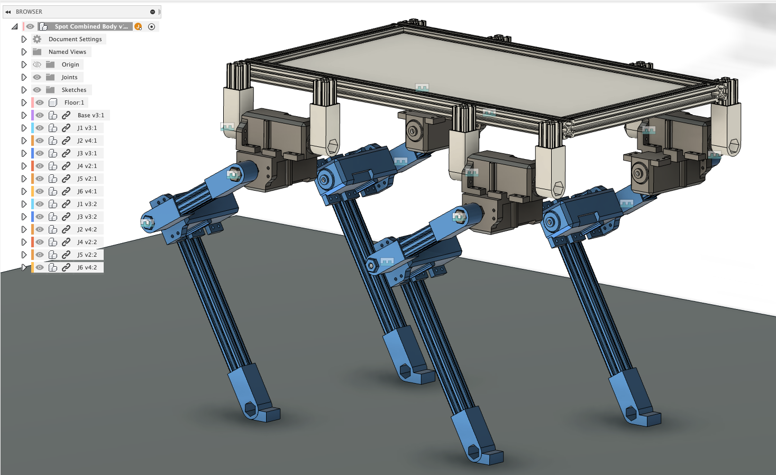

Figure CAD Compon

To import large models into ADAMS the model needs to be simplified by combining bodies. Our quadruped can be simplified to 14 bodies or sub-assemblies. The first component is the floor that the robot will be walking on. Second component is the main body that all the legs are mated to. Lastly, each of the four legs are made of three comments: the shoulder, the upper leg and lower leg. With the key sub-assembly identified each assembly will be combined into one single component. Multiple individual components can be combined into a single component by using the *COMBINE* utility in Fusion 360.

Figure Combine Utility

For Example, the Joint 3 of the quadruped robots consist of three components. These components are rigidly connected to each other and can be treated as a single assembly. To join these individual components, they were all selected and the combine utility used. The output is a single component made from a single body as shown in figure 5.

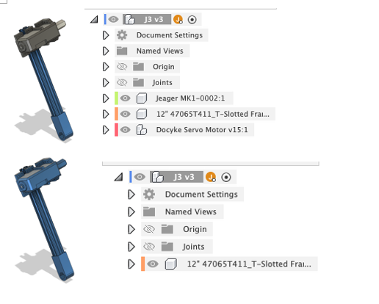

Figure Combined Body

Exporting File

With the model completed and the assembly simplified to under 20 components the file can now be exported from the CAD software. Adams supports a wide variety of file types. In this project we exported our model as a STEP file. With the STEP file generated it is time to move to the ADAMS software

Figure 6 Export CAD

1. ADAMS

Download

ADAMS can be downloaded directly from Hexagon online student portal. However, it is required to register a new student account prior to downloading the ADAMS software. To register a student account, a copy of the user’s student ID must be submit a to hexagon for account review. Adams software can be installed once the account is verified after 3-5 days.



Figure Student ID

Setup

After the ADAMS software is completely installed the next step is to create a new project. A new project can be made by selecting “New Model” and configuring the startup settings. The project name and units of measurements can be changed at the user’s discretion.

Figure New Project Settings

Importing Model

With the new project initialized it is now time to import the CAD file created in Fusion 360. To import a new file, use the “File Import” command found in the settings bar. A pop-up menu will appear where the user will specify the import file name, file location, and choose a model name. For this project we imported a STEP file and chose the model’s name to be the same as the project name.

Figure Importing CAD

Once the model is imported it should be seen on the right viewport of the application. The imported model should appear in the correct orientation if the model was made so that the Y axis was vertical. If not, the model will need to be corrected at this time. All bodies imported can be seen under the bodies folder located on the left viewport.

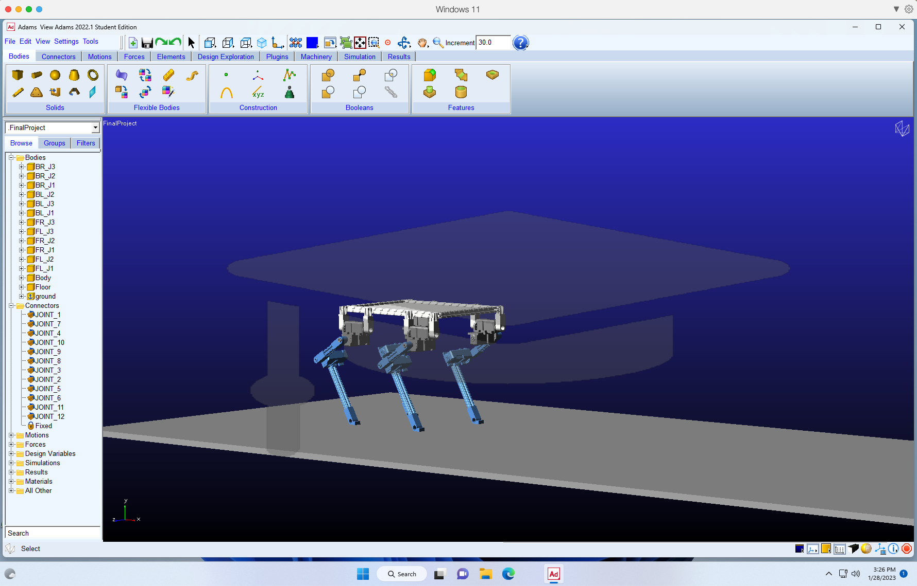

Figure Viewports & Imported Model

Bodies Configuration

The Next step is to configure the individual body properties. The name of each body can be specified to better descried the object. The material type of each body can be specified under the “modify” option when right clicking the individual component. For this project all bodies were assigned aluminum as their material type.

Figure Bodies Configuration

Connection Configuration

After configuring the individual components, the next step is to configure the connections between each component. A connection defines the degree of freedom between two bodies at a specific location. For example, an industrial robot with 6 DOF will have 6 joints. Each connection will be located at a joint where one body can slide or rotate relative to another body. Our quadruped contains 12 DOF and has 12 joints. An additional fixed joint was used to statically lock our floor.

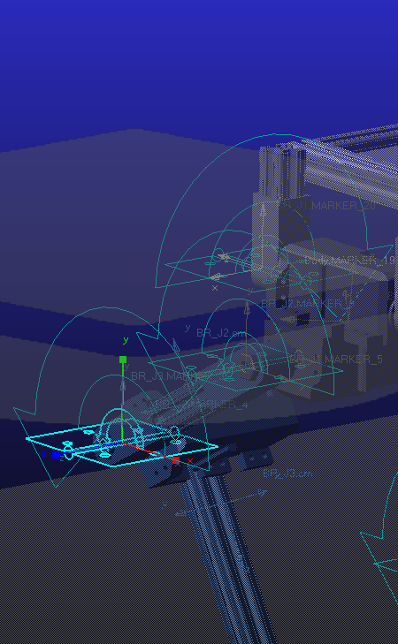

Figure List of Joints & Normal Grid Options

A variety of connection options can be selected under the connectors tab. For our application we selected hinged connections. A hinged forms a joint with 1 rotational DOF between two bodies at a specific point. Upon selection a joint an option menu will appear on the left viewport as shown in figure 13. To apply the desired joint, begin by selecting the 1st body in the right viewport, followed by selecting the second body. Lastly, specify the connection location/point. A center of rotation axis will appear normal to the normal grid and the selected point, as shown in figure 14. The normal grid orientation can be modified by selecting the normal grid option icon as shown in figure 12.

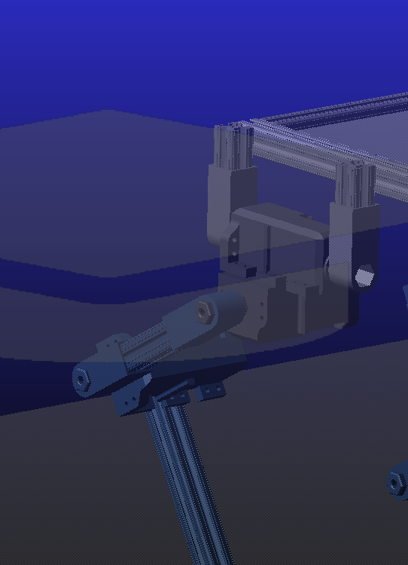

Figure Creating a Joint

After forming a joint connection, it will appear on the left side viewport, as seen in figure 12. After forming a joint connection verify that the joint is properly configured. Correctly configured joints are critical to the final motion simulation. Each joint can be modified to edit body order which will determine the positive and negative as shown in figure 14.

Figure Modifying a joint

Forces Configuration

The next step is to configure the forces of the model. Our model contains two types of forces, the force due to gravity and the force of each leg interacting with the floor. The gravitational force is automatically configured when specifying the material type of each body and the direction of gravity. All other forces will need to be manually configured.

Figure Contact Forces

A wide variety of forces can be selected under the forces tap. As mentioned, the only other type of force used in our simulation is the interaction force generated by each leg colliding with the static ground. This type of force interaction is called a contact force as shown in figure 16. Each body that interacts with the floor requires a contact force. Four contacted forces were used in our simulation.

Figure Select a Contact Force

To configure a contact force, begin by selecting the static force icon found in the special forces group under the force tab. Under the “I Solid” settings select top face of the floor as the first body. Under the “J Solid” settings select the face of the leg which interacts with the floor. The contact force can be successfully applied after both bodies are define. Repeat these procedures for all four independent legs.

Figure Contact Settings

After successfully creating the contact forces the next step is to define the friction force between the leg and floor. The friction force is critical to the walking robot ability to move across the surface without slipping. Each contact force can be modified, and a friction force applies as shown in figure 17. For this project we used the coulomb function to determine the friction forces.

Motion Configuration

last step needed for the simulation is to configure the motion. A motion function will need to be defined for each joint as shown in figure 18.

Figure Joint Motion

A joint’s motion function will control the rotation or translation of the joint during the simulation cycle. To create a new motion function, select the desired motion type under the motion tab. Then select the joint connection to apply the motion function to. For this project we will only be using the hinged motion function as shown in figure 18.

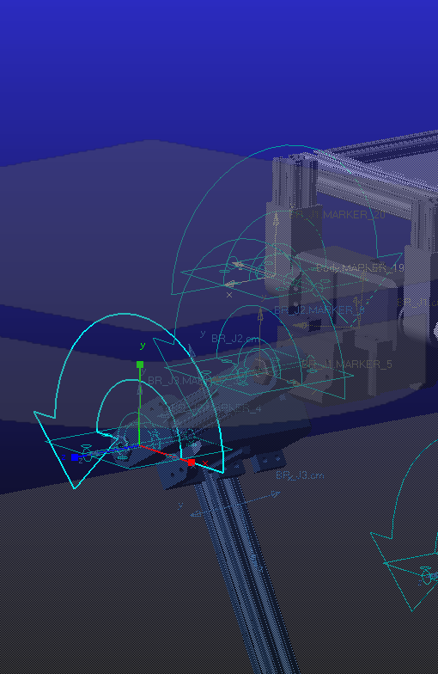

Figure

Under the joint motion settings, define the joint motion type as “function”. Select the function settings to open the function builder window. Under the function builder the user will write the Step function that will control the simulated motion. A step function specifies the motion a joint will make at a specific time. The step function is written with five inputs. The first input specified the type of step function, a time function was used for this project. The second input specify the time this step function begins. The third input specify the starting joint position. The fourth input specify the desired end time of the function. The fifth input specifies the final joint position.



Figure Step Function

Figure Function Builder

Before developing a step motion sequence, it is useful to plan out the desired motion. For this project each leg will transition from a forward position (yellow) and a backward position (red) as shown in figure 22. This ideal position informs us the joint angles to use in the step function. To make the motion between the two position a sequence of intermediate steps was chosen and is shown in figure 22.

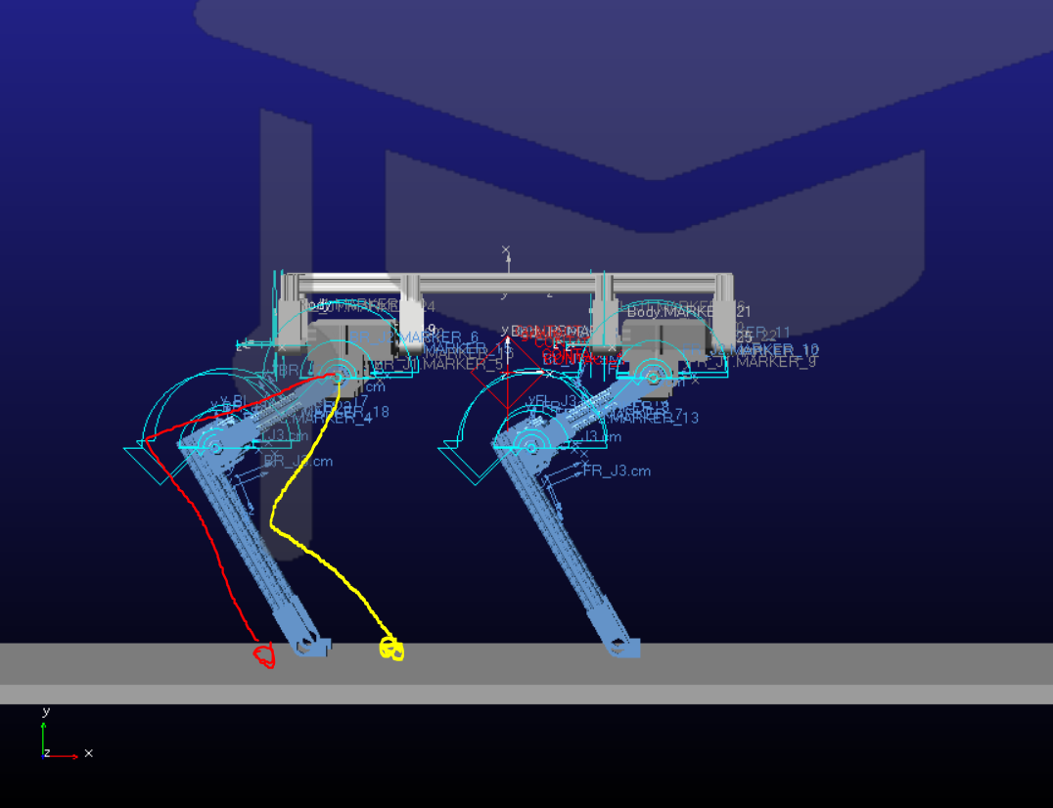

Figure Joint Pathways

After planning out the ideal pathway for each leg we moved onto developing the specific step functions for each joint. Each leg consists of three joints, a waist joint, a hip joint, and a knee joint. After some trial and error, a list of step functions was generated for each leg. Below is an example of the step function used for one of the quadrupeds’ legs. Each leg will be following the same general pathway so a similar step function will be used for each leg.

|  |  |
| --- | --- |
| Joint 10  Waist | STEP (time, 0.0, 0.0, 25, 0.0) |
| Joint 11  Hip Joint | STEP(time, 0.0, 0.0, 0.3, 0.0)+STEP(time, 1.0, 0.0, 2.0, 25d)+STEP(time, 2.0, 0.0, 2.5, 5d) + STEP(time, 2.5, 0.0, 3.0, -40d)+STEP(time, 3.0, 0.0, 3.5, 15d)+STEP(time, 3.5, 0.0, 4.0, 20d) +STEP(time, 4.0, 0.0, 4.5, 5d)+STEP(time, 4.5, 0.0, 5.0, -40d)+STEP(time, 5.0, 0.0, 5.5, 15d)  +STEP(time,5.5, 0.0, 6.0, 20d) +STEP(time, 6.0, 0.0, 6.5, 5d)+STEP(time, 6.5, 0.0, 7.0, -40d)  +STEP(time, 7.0, 0.0, 7.5, 15d)+STEP(time, 7.5, 0.0, 8.0, 20d) +STEP(time, 8.0, 0.0, 8.5, 5d)  +STEP(time,8.5, 0.0, 9.0,-40d)+STEP(time,9.0, 0.0, 9.5, 15d)+STEP(time,9.5, 0.0, 10.0, 20d)  +STEP(time,10.0, 0.0, 10.5, 5d)+STEP(time, 10.5, 0.0, 11.0,-40d)+STEP(time,11.0, 0.0, 11.5, 15d)  +STEP(time, 11.5, 0.0, 12.0, 20d) |
| Joint 12  Knee Joint | STEP(time, 0.0, 0.0, 0.3, 0.0)+STEP(time, 1.0, 0.0, 2.0, 20d)+STEP(time, 2.0, 0.0, 2.5, 15d)  +STEP(time, 2.5, 0.0, 3.0,-15d)+STEP(time, 3.0, 0.0, 3.5, 5d)+STEP(time, 3.5, 0.0, 4.0, -5d)  +STEP(time, 4.0, 0.0, 4.5, 15d)+STEP(time, 4.5, 0.0, 5.0, -15d)+STEP(time, 5.0, 0.0, 5.5, 5d)  +STEP(time, 5.5,0.0, 6.0, -5d) +STEP(time, 6.0, 0.0, 6.5, 15d)+STEP(time,6.5, 0.0,7.0, -15d)  +STEP(time, 7.0, 0.0, 7.5, 5d)+STEP(time, 7.5, 0.0, 8.0, -5d)+STEP(time, 8.0, 0.0, 8.5, 15d)  +STEP(time, 8.5,0.0, 9.0, -15d)+STEP(time, 9.0,0.0, 9.5, 5d)+STEP(time, 9.5,0.0, 10.0, -5d)  +STEP(time, 10.0, 0.0, 10.5, 15d)+STEP(time, 10.5, 0.0, 11.0, -15d)+STEP(time, 11.0, 0.0, 11.5, 5d)  +STEP(time, 11.5, 0.0, 12.0, -5d) |

Simulation

The model is now fully defined the simulation can now be executed. The objective of our simulation is to demonstrate a successful quadruped locomotion. To open the simulation control, select the simulation gear icon as shown in figure 23. For our simulation we specified a duration of 15 seconds as shown in figure 23. The number of steps in the simulation will determine the framerate of the simulation. We specified a step of 10,000 for our simulation.

Figure Simulation Controls

Once the simulation control is configured the simulation can be executed by pressing the play button shown in figure 23. After a few trials a successful simulation was made where the robot was able to walk 15 meters.

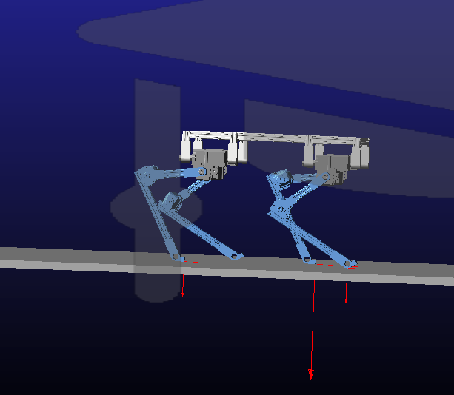

Figure Robot Walking

Figure 25 and 26 shows the distance and velocity of the robot during the simulation period. The robot was able to travel 1.5 meters with a constant velocity as shown in figure 25. As seen in the velocity chart the robot had a smoothly accelerate and decelerate between each step.

Figure Robot Displacement (Distance walked)

Figure Robot Velocity

Each joint of the robot was controlled by a step function, and the motion generated by the step function can be exported as a chart. Figure 27 and 28 shows the angle of all the joints in the front two legs of the robot over the simulation period. As shown in the chart each joint follows a cyclical motion.

Figure Joint 1, 2, 3

Figure Joint 4, 5, 6

1. CONCLUSION

The use of simulations has become critical for product development. With the use of simulations, a system can be tested then mechanical and software improvements can be implemented in a time effective and cost-effective manner. The goal of our project consists of the successful modeling and simulation of a four–legged walking robot. Our robot was drafted using Fusion 360 and the simulation was conducted using ADAMS. With ADAMS we were able to successfully simulate our quadruped locomotion. Our quadruped consisted of 12 joints, with a custom-made step function script that powered each joint motion. After many trials and errors, we were able to make a functional walking gait. Our robot traveled 1.5 meters at a constant velocity in a span of a 15 second simulation.

1. ACKNOWLEDGEMENTS

Final Project Video Link:

<https://youtu.be/NbEPwO2pHws>

1. REFERENCES

*Adams Student*. (n.d.). Retrieved from Hexagon: https://hexagon.com/products/adams-student-edition

Jenkins, J. (n.d.). *Adams Simulation*. Retrieved from Github: https://github.com/JenkinsRobotics/AdamsSimulation